Renewable Energy Research Task

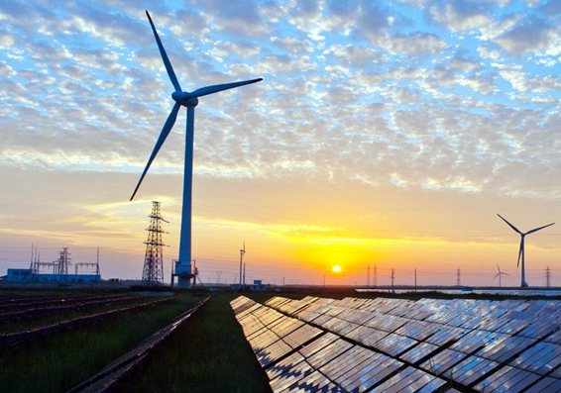

Name: ____________________________

Renewable Energy Research Project

**Your task:** Research renewable energy and create keynote to demonstrate your knowledge of one type of renewable energy.

**Your options include:**

|  |  |  |  |
| --- | --- | --- | --- |
| * Solar * Wind | * Hydroelectric * Biomass | * Tidal * Geothermal | * Hydrogen * Wave energy |

**Part 1: Research**

Complete the attached pages to conduct your background research.

**Part 2: Diagram (10 marks)**

Create a large, detailed diagram that shows how energy is captured and transformed into usable power (electricity) from your energy source. You include this in your final presentation.

**Part 3: Create a presentation and present as a virtual gallery walk (20 points)**

Your presentation should include the following (each dot point should be a separate slide):

* State your chosen renewable energy source
* Define renewable energy. How does it differ from the energy sources we currently use? (2)
* Where does your renewable energy source come from? (1)
* What makes your source renewable? (2)
* Diagram of how your energy source works (created in part 2)
* A Sankey diagram showing the energy efficiency of the transformation of energy from your original energy source to converting it to household electricity (3)
* Where and how your energy source is currently being used or developed (4)
* List of advantages for your energy source (3)
* List of disadvantages for your energy source (3)
* Other interesting facts (3)

**Please note:**

You will need to present your keynote to other members of your class. 10 mins max

All members of your group (and your teacher) must have access to your keynote.

Each member of your group must be able to talk an audience through your presentation.

## Research Pages

Definition of Renewable Energy.

|  |
| --- |
|  |

Three examples of renewable energy sources.

|  |
| --- |
|  |

Definition of Nonrenewable Energy.

|  |
| --- |
|  |

Three examples of nonrenewable energy sources.

|  |
| --- |
|  |

General description of your energy source.

|  |
| --- |
|  |

Where does your energy source come from?

|  |
| --- |
|  |

Explain why your energy source qualifies as renewable.

|  |
| --- |
|  |

Sankey diagram showing the energy efficiency.

|  |
| --- |
|  |

Where is your energy source currently being used? If it is not currently being used on a large scale, explain where and how it is currently being developed.

|  |
| --- |
|  |

List at least three advantages for your energy source (or more).

|  |
| --- |
|  |

List some disadvantages for your energy source.

|  |
| --- |
|  |

Describe at least three other interesting facts or information about your energy source.

|  |
| --- |
|  |

Make a decision! Is this a good energy source to use? Explain why or why not, based on what you have researched and taking the advantages and disadvantages into account.

|  |
| --- |
|  |

Labelled diagram

|  |
| --- |
|  |